**TASK 3:**

**IMAGE PROCESSING:**

Image processing is a method to perform some operations on an image, in order to get an enhanced image or to extract some useful information from it. It is a type of signal processing in which input is an image and output may be image or characteristics/features associated with that image. Nowadays, image processing is among rapidly growing technologies. There are two types of methods used for image processing namely, analogue and digital image processing. Analogue image processing can be used for the hard copies like printouts and photographs. Image analysts use various fundamentals of interpretation while using these visual techniques. Digital image processing techniques help in manipulation of the digital images by using computers. The three general phases that all types of data have to undergo while using digital technique are pre-processing, enhancement, and display, information extraction.

**WHY DO WE NEED IT?**

It is effectively used in computer vision, medical imaging, meteorology, astronomy, remote sensing and other related field. The aim of pre-processing is an improvement of the image data that suppresses unwanted distortions or enhances some image features important for further processing. Importance of digital image processing stems from two principal application areas: the first being the Improvement of pictorial information for human interpretation and the second being the Processing of a scene data for an autonomous machine perception. Digital image processing has a broad range of applications such as remote sensing, image and data storage for transmission in business applications, medical imaging, acoustic imaging, Forensic sciences and industrial automation. Images acquired by satellites are useful in tracking of earth resources, geographical mapping, and prediction of agricultural crops, urban population, weather forecasting, flood and fire control.Space imaging applications include recognition and analyzation of objects contained in images obtained from deep space-probe missions. There are also medical applications such as processing of X-Rays, Ultrasonic scanning, Electron micrographs, Magnetic Resonance Imaging, Nuclear Magnetic Resonance...

**IMAGE PROCESSING PROGRAM CODES:**

**CROP:**

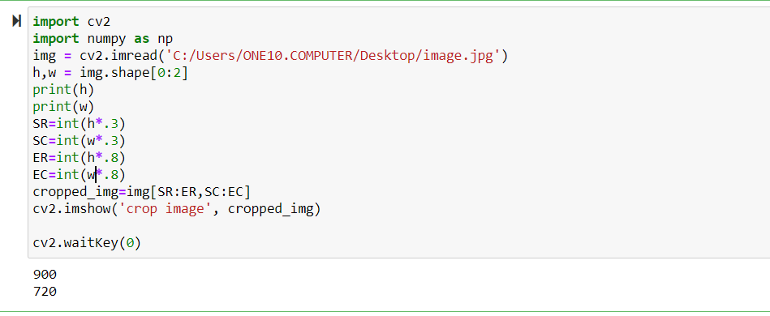

**OUTPUT:**

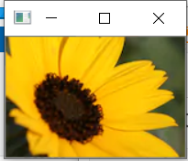 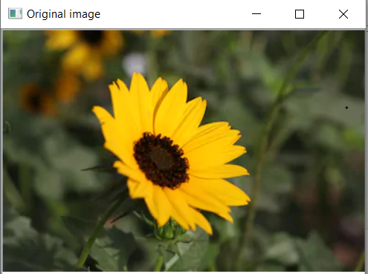

**RESIZE:**

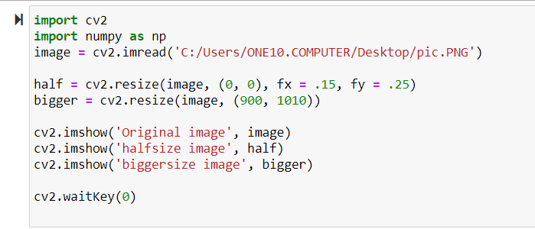 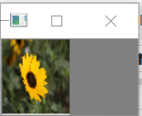 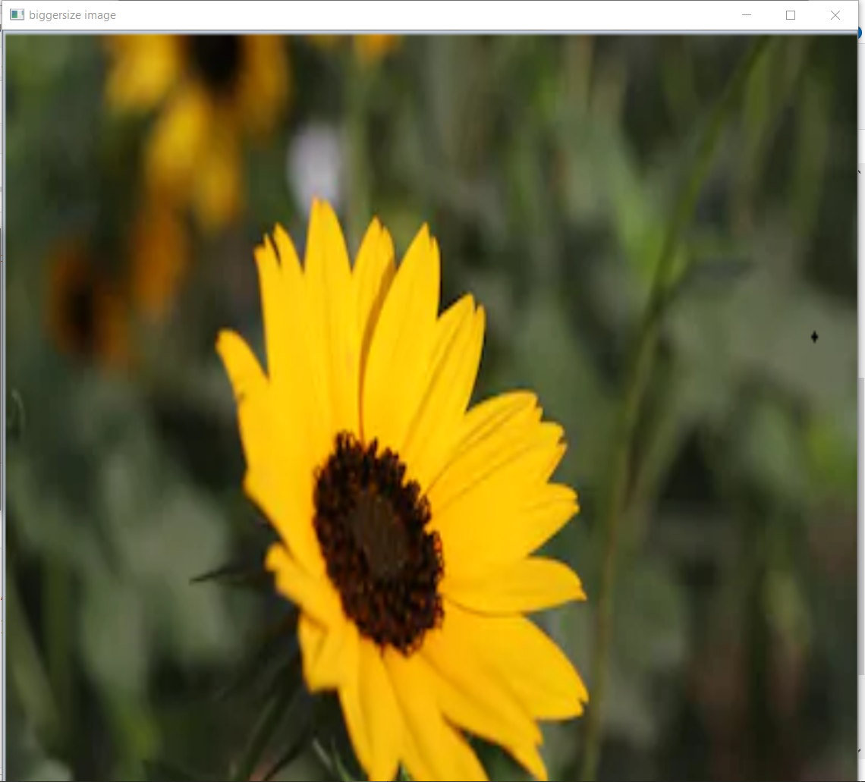

**ROTATE:**

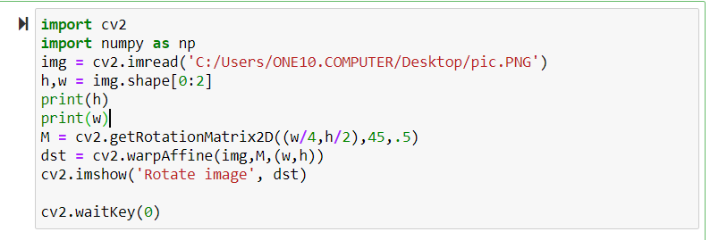

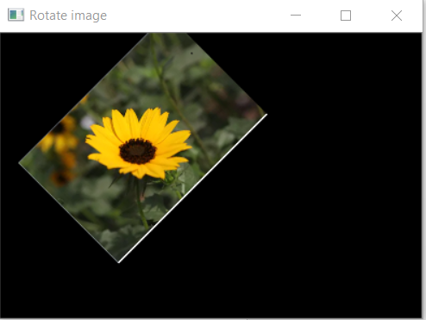

**FLIP:**

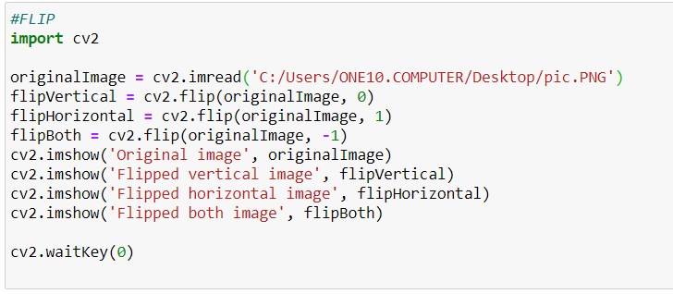

**OUTPUT:**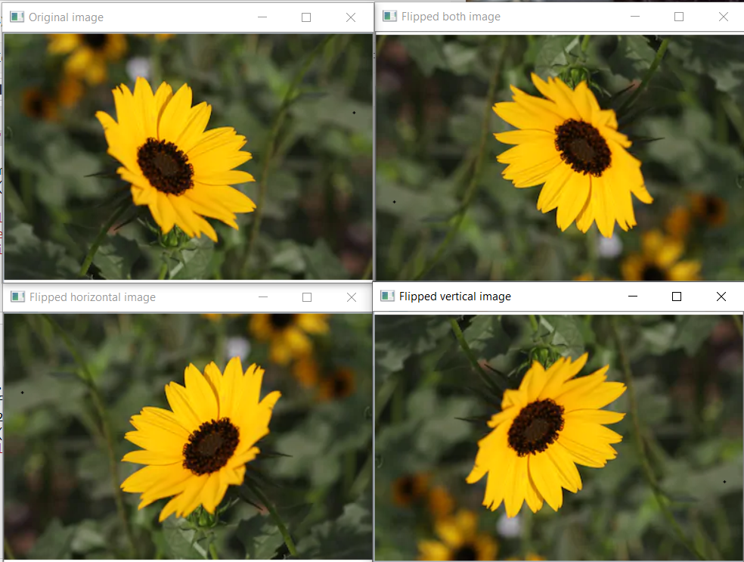

**BLACK AND WHITE:**

